**E-COMMERCE DATABASE PROJECT**

**DATA INTRODUCTION:**

This Project consist of one Table of E-commerce website for 5 months October 2020-February 2021.

The table consisted of details of users using the website .

The abbreviations used are below:  
  
UTC-Universal Time Coordinated

IST – Indian Time Standard

**PROBLEM STATEMENT:**

Despite the huge usage of ecommerce website a section of the society still prefers offline stores. Why?

**Objective:**  
- To analyze the usage of ecommerce website.

- To provide suggestions for improving the business on basis of Findings.

**The data for the analysis has been attached below:**



The data in CSV file suggested that it had more than 8 Lakhs records or rows and nine fields or columns namely .

**My Work File:**



**MY WORK ON DATA :**

Firstly I disable safe update mode.



Then I removing UTC from event_time.

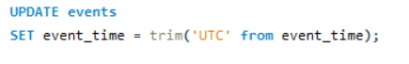

After removing UTC from event time then, I updated UTC to IST.

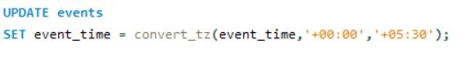

After that I updated price datatype into float.

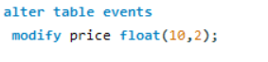

**After modifying data I started to analyse by listing various factors affecting business and**

**started to write query.**

* **Below are the factors which are affecting business basically:**

**1**. Month of Sales

**2**.Top Time of Visit

**3**.Top brands by Sale

**4**.Demand for Items

**5**.Frequency of Purchase  
**6**.Actual Time purchased

**Q1(First_Query)**

**Month of Sales:**

Here students are required to find months in decreasing order of sales and

also highest sales in which month and year and lowest sales in which

month and year with the help of SQL query.

**Query:**

* Sales by Desc.

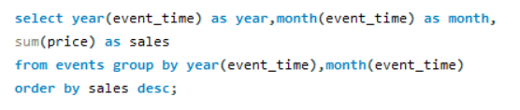

**Output:**

**Explanation:**

**Here we need to calculate heighst sales monthly and yearly**

**In descending order.**

So we need to extract year and month from event_time and as

“Year” and “month” respectively and then we need to take **sum of price as “sales”**

From events .

And then we need to make group of year(event_time) and month(event_time)

So we use **Group by clause here**.

And then we need firstly descending order of “sales” and highest sales.

So we need to use **Order by clause here.**

**Q1(Second_Query)**

Here students are required to find months in decreasing order of sales and

also highest sales in which month and year and lowest sales in which

month and year with the help of SQL query.

* Sales by asc.

**Query:**

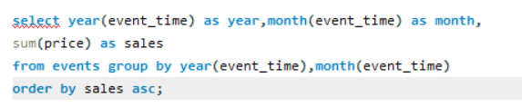

**Output:**

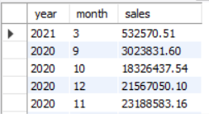

**Explanation:**

**Here we need to calculate lowest sales monthly and yearly**

**In ascending order.**

So we need to extract year and month from event_time and as

“Year” and “month” respectively and then we need to take **sum of price as “sales”**

From events .

And then we need to make group of year(event_time) and month(event_time)

So we use **Group by clause here**.

And then we need firstly Ascending order of “sales” and Lowest sales.

So we need to use **Order by clause here.**

**Q2(First_Query)**

**Top Time of Visit:**

Here Students are required to calculate the time for viewing, adding

to cart and Purchase time with help of SQL query and need to

confirm if mostly viewed and added to cart time is similar to Purchase time or not.

select * from events

**Query:**

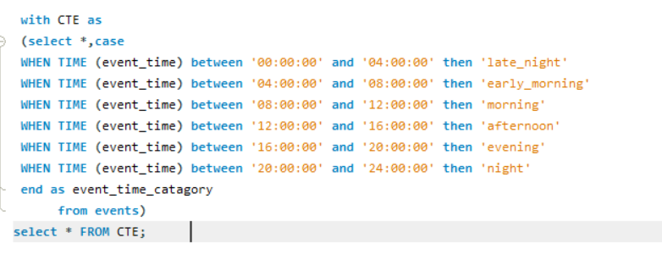

**Output:**

**Explanation:**

Firstly we need to divided event_time in to time category

So we make time category temporary column as event_time_category.

We make category as follows.

12am-4am 🡪Late Night

4am -8am🡪Early Morning

8am-12pm🡪 Morning

12pm - 4pm 🡪Afternoon

4pm-8pm 🡪Evening.

8pm 🡪12pm Night.

We use CTE with statements for making common table expression.

So select all from CTE.

Our new column “event_time_catgory”is ready.

So now we can easily analyse data.

**Q2(Second_Query)**

Top Time of Visit:

Here Students are required to calculate the time for viewing, adding

to cart and Purchase time with help of SQL query and need to

confirm if mostly viewed and added to cart time is similar to Purchase time or not.

select * from events

**Output:**

**Explanation**:

**So here need to check total events occurred in event_time_catagory.**

Here we select event_type,event_type category,count all as event type category.

From CTE .Then group by event_time_catagory and event_type.Order by total_event type.

So our result is ready. We got total_event_type

**Q2(Third query)**

**Query:**

Top Time of Visit:

Here Students are required to calculate the time for viewing, adding

to cart and Purchase time with help of SQL query and need to

confirm if mostly viewed and added to cart time is similar to Purchase time or not.

select * from events

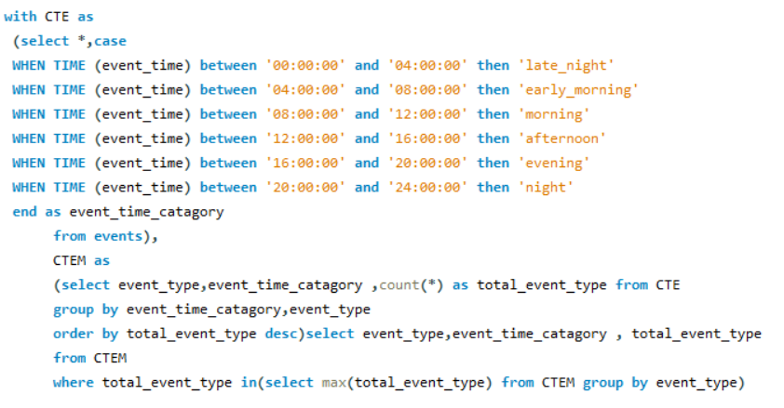

**Output:**

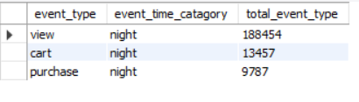

**Explanation:**

**Mostly viewed and added to cart time is similar to Purchase time .**

We have find **max of total event type in every event_type and the event time category**

Is coming same which is **night**.

**Q3**

**Top brands by Sale:**

Here Students are required to find Top 6 brand w.r.t

Sales which is the Top Brand followed by other brand with the help of SQL query.

**Query:**

**Output**:

**Explanation:**

Firstly we need to select brand,sum of price as total_price.

And here we needs to use **where** **condition**

In where condition we write **event_type =’purchase’**

After where condition we need to made brand **Group**

And order by brand need to make it in **Descending order**

**At the end of query select and show top 6 brand**

So here we use **LIMIT** function so here we write **LIMIT6.**

**Q4**

**Demand for Items**:

Here Students are required to find Top 6 Category which was

sold most number of times and should also show the count as well.

select * from events

**Query:**

**Output:**

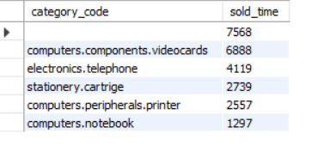

**Explanation:**

Here we need to find top 6 category .

Firstly we required to select category_code,

Count of category_id as sold times because category_id is mention infront each event_type.

Then we use **where condition** because we want purchase time quantity as sold time

So we use **event_type = ‘purchase’**

After that we made groups by category_code

We need top 6 category .

So we use sold_time is in **descending order .**

We need only top 6 category .

So we use **LIMIT** function.

LIMIT 6.

**Q5**

**Frequency of Purchase:**

Here Students are required to find count of Users who has purchase at each time i.e.

number of users purchasing once,twice,thrice etc once in a given time span of 5 months

and also Maximum number of Times one person has purchased in a given time span of 5 months

select * from events

**Query:**

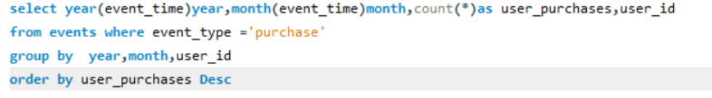

**Output:**

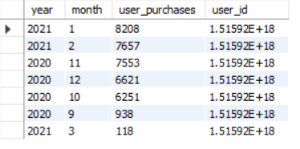

**Explanation :**

Here we need to find **Frequency of Purchase** in given time span of **Five_months.**

Firstly we required to extract year and month from event_time .

Then count all from events as user_purchases.

After that we need to use **where condition** for select only **purchase event_type.**

So we write **event_type = ‘purchase’.**

And made **group of year and month**,**user_id**

At the last we make our results in to **desending order.**

**Q6**

**Actual Time purchased :**

Here Students have to find the number of times that the item has actually been purchased

after the users have viewed the items i.e. the query should give result for actual number of times purchased.

Also query should be written to find the number of times the item has been viewed.

**Query:**

**Output:-**

**Explanation of query:**

Here we need to find actual time purchase after the users have viewed the items

So firstly we need to **select event_type and count all from events**.

And then we need to **make groups by event_types.**

**Conclusion**

So I analyse data and make some conclusions below

1. **Month of Sales:**

We calculated monthly sales of our E-commerce website.

The highest sales is in 1st month 2021 Is **33508355.90**

Lowest sales is in 3rd month 2021 Is 532570.51

**2.Top Time of Visit:**

Rather than viewing it hour wise I made time category of 4 hrs each

Here we make time bins for event_time_catagory as follows

12am-4am 🡪Late Night

4am -8am🡪Early Morning

8am-12am🡪 Morning

12pm - 4pm 🡪Afternoon

4pm-8pm 🡪Evening.

8pm 🡪12pm Night.

Night time (8pm – 12pm)is the time where users are very frequently viewing and purchasing.

So this is time here we can really target users giving some offers and coupons.

Views in night(8pm – 12pm.)

So final conclusion is top time of visits and purchase is night(8pm – 12am)

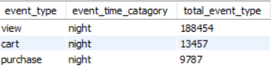

**3.Top brands by Sale:**

We find top 6 brand by its total _sales as total price

Most of the products have not updated their brand name we can clearly see in our output so would have to update the brand name of the products so that it not would create any future error and it would to good look at or keep tack of.

Our top 6 selling brand is following:

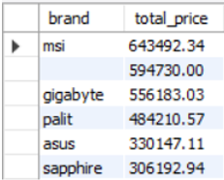

**4.Demand for Items:**

Here we find our top 6 selling catgory

Most of the products have not updated their category_code and brand name we can clearly see in our output so would have to update the category_code and brand name of the products so that it not would create any future error and it would to good look at or keep tack of.

Our top 6 selling category as follows:

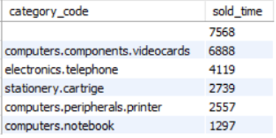

**5.Frequency of Purchase:**

Here wefind Frequency of purchase of products by customer in the order of month.

So here only one user in data .

So frequency of user purchases is highest in 1st month of 2021.

And frequency of user purchases is lowest in 3rd month of 2021.

So final conclusion is the frequency of user purchases is average in 2nd,11th,12th,10th

But frequency of user purchases is very low in 9th and 3rd month in given data.

Specially we need focus on increase user_purchases frequency of 9th and 3rd month of the given data.

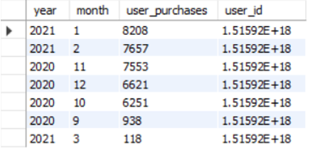

**6.Actual Time purchased:**

Here we need to find how many users are visited the site and after that how many users purchase the products.

So in this given data

Viewed product by user is **793748**

Actual time purchased by user is **37346**

**In percentage form Actual time purchase percentage is 4.70%**

So **Actual Time purchased** percentage is very low so our business is not going good so we need to

create some offers and coupon for the customer .

**Answer of problem_statement:**

**Despite the huge usage of ecommerce website a section of the society still prefers offline stores. Why?**

**Answer:**

Indian still prefer offline mode. India a developing country, which possess a large  
number of youth power & tremendous opportunity for world market . Recently mobile revolution have taken place in India & continuous growing in larger pace. In couple of few years things have changed many much , now these days one can see a low end or  
even a high end smartphone in the hand of a normal indian layman. A lots of telecom  
companies like Airtel, vodafone, bsnl, tata docomo, idea etc have covered almost every  
corner of india with a net of telecommunication tower & cables. Now these days 2g/3g/4g, online payments, shopping etc are not remain alien words for a  
normal Indian layman. These days lots of people from India making online transactions with the help of phone or laptop etc. But still a lots of people actually a vary big segments of Indian populations doesn't believe in online world. They by no doubt prefer offline mode for financial & other transactions than online mode. Main reason behind this is lack of proper knowledge about internet & also fear of scam &  
scam like sites etc. You may find very easily a Indian standing in a  
Que for applying for reservation of train or paying bills ,although at that time he/she possess in its pocket a high end phone capable of doing all online stuff .  
 Reason behind same is lack of trust on online world & service providers. People from India still prefer to purchase from local market a local brand  
instead from a reputed online shopping site who may be offering a leading brand in affordable price with doorstep delivery. Indian prefer offline activity in place of online but things are changing .We are growing & learning. Later or sooner situation will improve & we will able to see a lots of Indian trusting online world.

Indians usually buy those things which they can first **see** and **touch**and then **bargain** according to their perception about the product. While buying online, one cannot do these things. Although the mindset is changing now and more and more people are trying online buying but still majority believes that it is better to get a feel before they buy anything.

Even if the market is now changing.